Test Plan

Project - Sonic Sargam

INTRODUCTION

This document will test the site's login feature. The goal is to ensure the login system functions correctly, works as expected, is user-friendly, and performs well on every platform. The approach involves creating structured test cases. The strategy and scope of testing to ensure that the login system is functional, secure, user-friendly, and performs reliably across devices and browsers.

AUT- https://newsonicsargam.netlify.app/login.html

OBJECTIVE

To the login module:

Authenticates users with valid credentials.

Prevents access with invalid or blank inputs.

Redirects users appropriately after login.

Handles errors and exceptions gracefully.

Functions well on different browsers and devices.
SCOPE

- In-Scope
- Functional testing of the login page.
- Usability testing
- UI validation
- Error message check
- Check on desktop and mobile browsers.
- Out of Scope
- Performance testing
- Forgot Password, Signup
Testable Features

Username and password fields.

Login button.

Input validation (blank, special characters).

Show/Hide password toggle.

Navigation on successful login.

Error messages for wrong credentials.
Testing Approach
- Manual Testing using Chrome's newer version.
- Cross-browser and responsive testing.
- Boundary Value Analysis for input fields.
- Negative testing with invalid credentials.
- Use of checklists and test case documents.
- Logging defects in a defect report document.
Testing Environment
- QA Environment
Operating System
- Windows 11 and above
- Browsers: Chrome
Roles & Responsibility

Role | Responsibility
Test Lead → | Plan, coordinate, and approve testing activities
Test Engineer → | Design and execute test cases, report bugs
Developer → | Fix bugs and support the testing team
Project Manager → | Approve final test results and sign off

Test Schedule

Activity | Start Date | End Date
Test Plan Creation | May 1, 2025 | May 3, 2025
Test Case Design | May 2, 2025 | May 4, 2025
Test Execution | May 4, 2025 | May 5, 2025
Defect Reporting & Retesting | May 5, 2025 | May 8, 2025
Final Review & Sign-off | May 8, 2025 | May 8, 2025

Test Deliverables

Deliverables | Description | Responsible Owner | Target Completion Date
Test Plan | Outlines the testing approach, strategies, and scope for the Amazon web application. | Akash yadav | 1 May 2025
Test Scenarios | Test Scenarios created for all mentioned objectives | Akash yadav | 2 May 2025
Test Cases | Test Cases created for both functional testing and compatibility testing | Akash yadav | 4 May 2025
Bug Reports | Detailed description of the defects identified in different versions of application. | Akash yadav | 6 May 2025
Summary Report | Detailed overview of the status of all test cases conducted, along with suggestions for improvement. | Akash yadav | 8 May 2025

Entry & Exit Criteria

Entry Criteria | Exit Criteria
- Login page is developed and deployed.  - Test environment is ready.  - Requirements are documented. | - All critical and major defects are fixed and retested.  - Test case execution is 100% completed.  - Test summary report is reviewed and approved.

Tools
- Browser DevTools (for inspecting elements)
- Google Sheets
- Google Docs
- Snipping Tool (for defect screenshots)

Risks and Mitigation Plan

Risk | Mitigation
Unclear requirements → | Frequent communication with develope
Delayed bug fixes → | Prioritize critical defects early
Browser incompatibility → | Conduct cross-browser testing early

Approval
Below are the documents required for Client Approval :
- Test Plan
- Test Scenarios
- Reports
Testing will only continue to the next steps once these approvals are done

MindMap

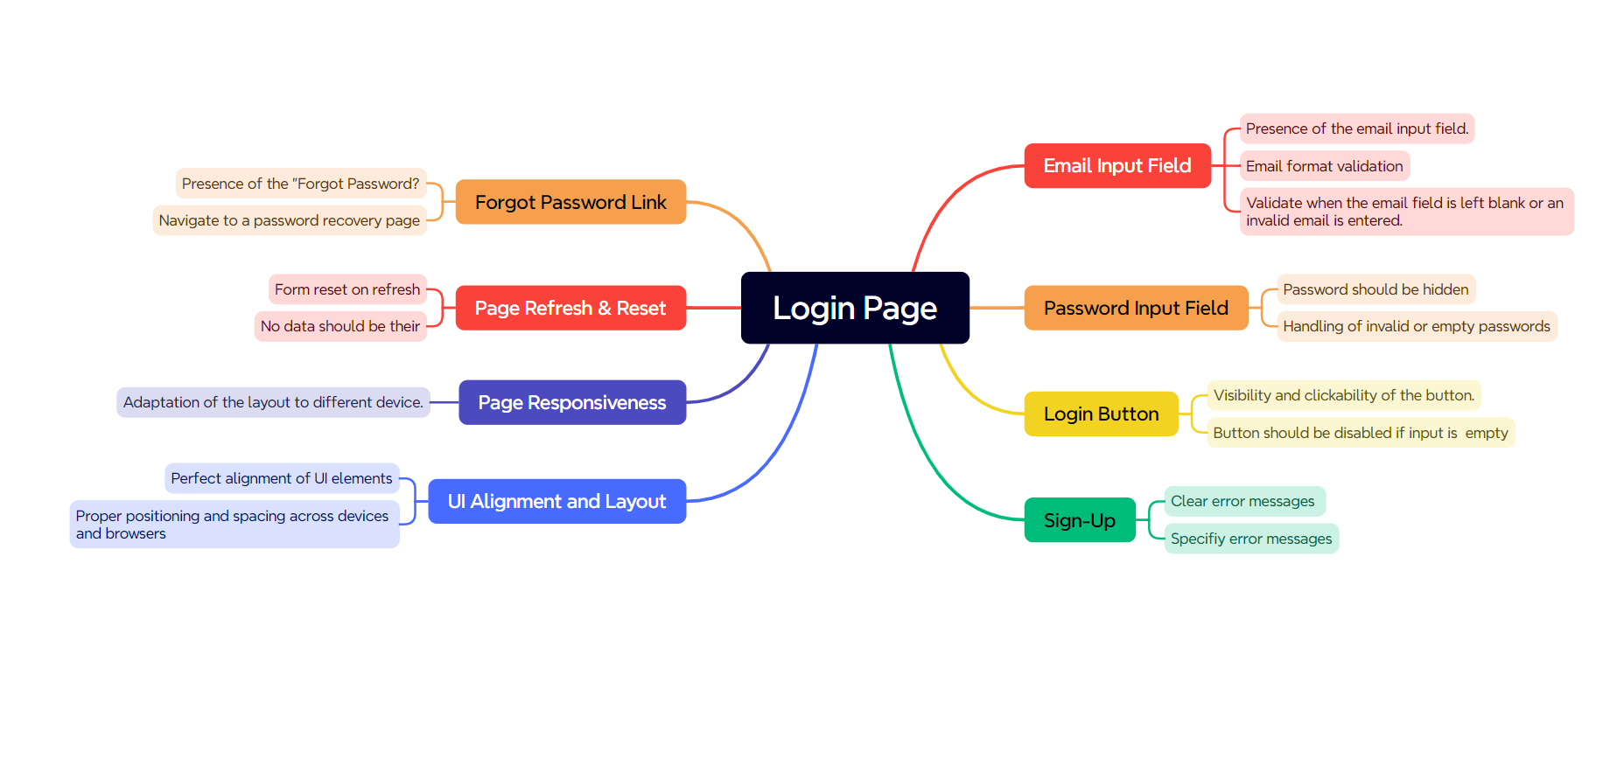

Prepared By - Akash Yadav

Date- 03/05/2025

Test Plan

Project - Sonic Sargam

